|  |  |
| --- | --- |
|  |  |

**DEPARTMENT OF ELECTRICAL & ELECTRONICS ENGINEERING**

CONSOLIDATED REPORT ON

|  |  |  |  |
| --- | --- | --- | --- |
| |  |  | | --- | --- | |  | **SRI VENKATESWARA ENGINEERING COLLEGE**  Karakambadi Road, Tirupati - 517 507, A.P.  Accredited by NAAC, Approved by AICTE & Permanently Affiliated to JNTUA  Recognized under section 2(f) & 12 (B) of UGC act 1956. | |  |

**FACULTY FEEDBACK ON CURRICULUM**

|  |  |  |  |  |  |  |  |  |
| --- | --- | --- | --- | --- | --- | --- | --- | --- |
| SLNO | Statements | **Excellent-5** | **Very Good-4** | **Good-3** | **Average-2** | **Below Average-1** | **Sum** | **%** |
| 1 | Do you feel that the curriculum is defined in a way to clarify your teaching goals and what you expect your student to learn? | 30 | 8 | 4 |  |  | 194 | 92.38 |
| 2 | Is the curriculum sufficient to bridge the gap b/w industry standards/current global scenario and academics? | 28 | 10 | 4 |  |  | 192 | 91.43 |
| 3 | Is the timely coverage of curriculum possible in the mentioned number of hours? | 32 | 8 | 2 |  |  | 198 | 94.29 |
| 4 | Sufficient reference material and books are available for the topics mentioned in the curriculum? | 27 | 9 | 6 |  |  | 189 | 90.00 |
| 5 | The evaluation methods mentioned in the curriculum are sufficient for providing assessments? | 35 | 5 | 2 |  |  | 201 | 95.71 |
| 6 | Curriculum suitability for the course | 26 | 8 | 8 |  |  | 186 | 88.57 |
| 7 | The curriculum/course of this subject increased my knowledge and perspective in the subject area | 34 | 7 | 1 |  |  | 201 | 95.71 |

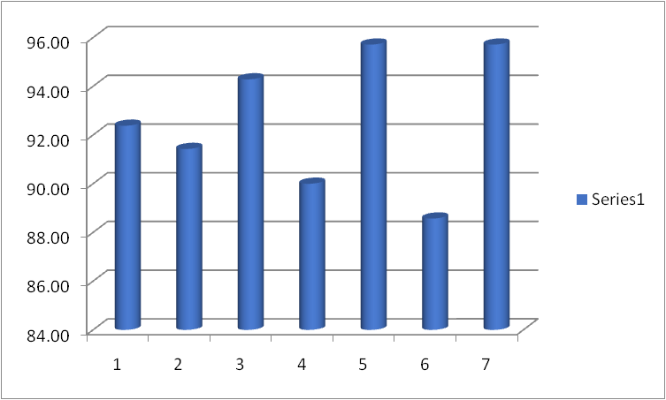

**HOD**